Software Requirements Specification
for
Automated Attendance System
Version 1.0 approved

Prepared by

Darji Chintan | 18CP023 | chintandarji155@gmail.com
Variya Meet | 18CP022 | meetvariya00@gmail.com
Patel Deep | 18CP204 | deeppatel76506@gmail.com
Organization: Birla Vishvakarma Mahavidyalaya
Instructor: Hemant D. Vasava
Course: Software Engineering(3CP07)
Date: 12/03/2021
Table of Contents
Table of Contents ii
Revision History ii
1. Introduction 1
1.1 Purpose 1
1.2 Document Conventions 1
1.3 Intended Audience and Reading Suggestions 1
1.4 Product Scope 1
1.5 References 1
2. Overall Description 2
2.1 Product Perspective 2
2.2 Product Functions 2
2.3 User Classes and Characteristics 2
2.4 Operating Environment 2
2.5 Design and Implementation Constraints 2
2.6 User Documentation 2
2.7 Assumptions and Dependencies 3
3. External Interface Requirements 3
3.1 User Interfaces 3
3.2 Hardware Interfaces 3
3.3 Software Interfaces 3
3.4 Communications Interfaces 3
4. System Features 4
4.1 System Feature 1 4
4.2 System Feature 2 (and so on) 4
5. Other Nonfunctional Requirements 4
5.1 Performance Requirements 4
5.2 Safety Requirements 5
5.3 Security Requirements 5
5.4 Software Quality Attributes 5
5.5 Business Rules 5
6. Other Requirements 5
Appendix A: Glossary 5
Appendix B: Analysis Models 5
Appendix C: To Be Determined List 6

Revision History
Name | Date | Reason For Changes | Version
Darji Chintan | 12/3/2021 | Updated information -System features and business rules | 1.0

Introduction

Purpose
The purpose of this document is to present a detail description of the Automated Attendance System. It'll explain the purpose and features of the software, the interfaces of the software, what the software will do, the constraints under which it must operate and how the software will react to external stimuli. This document is intended for both the end users and the developers of the software.

Document Conventions
This document will use IEEE format. For clarity, acronyms and technical jargon, deemed uncommon by the author, will be annotated and included in the glossary. The format for headings is as followed: Major headings are in bold 18pt font, and concurrent headings in bold 14pt font. Sections are in the format of x. y, where x and y are real, positive integers.

Intended Audience and Reading Suggestions
The intended audience is any institute admin, who will be implementing and testing the automated attendance system. The document is to be utilized by the admin to evaluate software's design and features.

Product Scope
The Attendance Management System will allow the teacher in charge to maintain a record of attendance of student in their respective classes from a pc. Also, the system will permit the teacher in charge to maintain all the essential details regarding a particular student. The goal is to provide Faculty with an easy, portable solution to attendance record maintenance and attendance statistics.

References
Software Engineering A Practitioner’s Approach-Roger S Pressman

Overall Description

Product Perspective
The attendance management is intended to replace the manual model of attendance record keeping in paper records. The call of student and filling attendance in paper is replaced by interaction of faculty and the attendance system. Faculty can be able to see details about any individuals and his/her attendance. The features expressed in this software requirements specification documentation are intended to be fully implemented in version 1.0 the system will be developed in such a way to provide easy addition of enhanced features.

Product Functions
The main feature of the Automated Attendance System is that it keeps a record of all essential details of each individual student. The system allows the faculty to view student's attendance record for the specified class. Finally, another feature of Automated Attendance System is the flexibility and ease of use.

User Classes and Characteristics
There are n number of faculty members at the university and it is estimated that almost all faculty members will utilize the Attendance management System. Faculty will have multiple classes and interaction with the system will occur at multiple times throughout the day from multiple faculties. The faculty should be allowed to take and view attendance records at any desirable time. All faculty have internet access through their pc’s. This provides the backbone of the attendance management system.

Operating Environment
/- "0 &'
1'-
/- 20 1'-
13

/- 40 


/- 50Pentium 3.0 GHz or higher RAM must be 1 Gb or more and Hard Drive
10 GB or more
/- "0 &'
1'-
/- 20 1'-
13

/- 40 


/- 50Pentium 3.0 GHz or higher RAM must be 1 Gb or more and Hard Drive
10 GB or more
/- "0 &'
1'-
/- 20 1'-
13

/- 40 


/- 50Pentium 3.0 GHz or higher RAM must be 1 Gb or more and Hard Drive
10 GB or more
/- "0 &'
1'-
/- 20 1'-
13

/- 40 


/- 50Pentium 3.0 GHz or higher RAM must be 1 Gb or more and Hard Drive
10 GB or more
/- "0 &'
1'-
/- 20 1'-
13

/- 40 


/- 50Pentium 3.0 GHz or higher RAM must be 1 Gb or more and Hard Drive
10 GB or more
/- "0 &'
1'-
/- 20 1'-
13

/- 40 


/- 50Pentium 3.0 GHz or higher RAM must be 1 Gb or more and Hard Drive
10 GB or more
/- "0 &'
1'-
/- 20 1'-
13

/- 40 


/- 50Pentium 3.0 GHz or higher RAM must be 1 Gb or more and Hard Drive
10 GB or more
/- "0 &'
1'-
/- 20 1'-
13

/- 40 


/- 50Pentium 3.0 GHz or higher RAM must be 1 Gb or more and Hard Drive
10 GB or more
/- "0 &'
1'-
/- 20 1'-
13

/- 40 


/- 50Pentium 3.0 GHz or higher RAM must be 1 Gb or more and Hard Drive
10 GB or more
/- "0 &'
1'-
/- 20 1'-
13

/- 40 


/- 50Pentium 3.0 GHz or higher RAM must be 1 Gb or more and Hard Drive
10 GB or more
/- "0 &'
1'-
/- 20 1'-
13

/- 40 


/- 50Pentium 3.0 GHz or higher RAM must be 1 Gb or more and Hard Drive
10 GB or more
/- "0 &'
1'-
/- 20 1'-
13

/- 40 


/- 50Pentium 3.0 GHz or higher RAM must be 1 Gb or more and Hard Drive
10 GB or more
/- "0 &'
1'-
/- 20 1'-
13

/- 40 


/- 50Pentium 3.0 GHz or higher RAM must be 1 Gb or more and Hard Drive
10 GB or more
/- "0 &'
1'-
/- 20 1'-
13

/- 40 


/- 50Pentium 3.0 GHz or higher RAM must be 1 Gb or more and Hard Drive
10 GB or more
/- "0 &'
1'-
/- 20 1'-
13

/- 40 


/- 50Pentium 3.0 GHz or higher RAM must be 1 Gb or more and Hard Drive
10 GB or more
/- "0 &'
1'-
/- 20 1'-
13

/- 40 


/- 50Pentium 3.0 GHz or higher RAM must be 1 Gb or more and Hard Drive
10 GB or more
/- "0 &'
1'-
/- 20 1'-
13

/- 40 


/- 50Pentium 3.0 GHz or higher RAM must be 1 Gb or more and Hard Drive
10 GB or more
/- "0 &'
1'-
/- 20 1'-
13

/- 40 


/- 50Pentium 3.0 GHz or higher RAM must be 1 Gb or more and Hard Drive
10 GB or more
/- "0 &'
1'-
/- 20 1'-
13

/- 40 


/- 50Pentium 3.0 GHz or higher RAM must be 1 Gb or more and Hard Drive
10 GB or more
/- "0 &'
1'-
/- 20 1'-
13

/- 40 


/- 50Pentium 3.0 GHz or higher RAM must be 1 Gb or more and Hard Drive
10 GB or more
/- "0 &'
1'-
/- 20 1'-
13

/- 40 


/- 50Pentium 3.0 GHz or higher RAM must be 1 Gb or more and Hard Drive
10 GB or more
/- "0 &'
1'-
/- 20 1'-
13

/- 40 


/- 50Pentium 3.0 GHz or higher RAM must be 1 Gb or more and Hard Drive
10 GB or more
/- "0 &'
1'-
/- 20 1'-
13

/- 40 


/- 50Pentium 3.0 GHz or higher RAM must be 1 Gb or more and Hard Drive
10 GB or more
/- "0 &'
1'-
/- 20 1'-
13

/- 40 


/- 50Pentium 3.0 GHz or higher RAM must be 1 Gb or more and Hard Drive
10 GB or more
/- "0 &'
1'-
/- 20 1'-
13

/- 40 


/- 50Pentium 3.0 GHz or higher RAM must be 1 Gb or more and Hard Drive
10 GB or more
OE 1: The attendance system shall function on the PC provided by the college. this entails the system to operate on the windows CE platform.
OE 2: The attendance system shall interface between windows CE designated to store the attendance records. The web server and database software have not been established at this point.
OE 3: The attendance system will record all the essentials details of each student.

Design and Implementation Constraints
'/ "0 +
'/ "0 +
'/ "0 +
'/ "0 +
'/ "0 +
'/ "0 +
'/ "0 +
CO-1: The time allotted for this project will be limited to the end of this semester.
CO-2: Programming is done in python, CSS, SQL, and HTML.

User Documentation
UD-1: The System will provide a hard copy of the user manual.

Assumptions and Dependencies
- We assume that the office personnel do all the data entry based and the correct values obtained from forms and registers.
- We assume that the computers that will use the software will be part of the college LAN.
- Users with administrator access should be careful in deleting on modifying any information knowingly or unknowingly which will lead to inconsistency of the database.
- The end users of this software are assumed to have basic level of computer knowledge i.e., point and click.

External Interface Requirements

User Interfaces
GUI along with meaningful frames and buttons.
Reports are generated as per the requirement.
Refer Appendix 2.

Hardware Interfaces
Hardware Environment: Intel core i3 - 8th gen and above
System Configuration: RAM 1 GB, HDD-10GB
Operating system: Windows 10/Linux.

Software Interfaces
Front end: HTML/CSS
Back end: Django/MySQL/SQLite

When invalid inputs are given to the modules then the error messages will be popped up to inform the user that the input provided is not taken by the database. When incomplete information is provided by the user and the user tries to submit the form to store the details in the database the system will pop up a message box asking the user to enter all the details required.

Communications Interfaces
The machine will have to be part of the college Local Area Network to access the central database.

System Features
4.1 Taking attendance
4.1.1: Description and Priority:
This feature is top priority feature of our project. In this project, we’re going to taking attendance using one's face data and compare it to our database and then mark the attendance. If we include specific priority components such as benefit have rating of 7, cost of 6, risk of 7 and so on.
4.1.2: Stimulus/Response Sequences:
Firstly user(student/faculty) log in into our system then system let them to edit their details
then user(student) will upload their photo and system will create a dataset from it. The user(faculty) will select their course from timetable and click on the "take attendance" button and the system will start taking attendance. If user asks for download attendance then the system will create report of the attendance taken.
4.1.3 Functional Requirements:
Easily track attendance information of students. Quickly produce single or multiple day attendance reports.

4.2 Analytics of attendance
4.2.1: Description and Priority:
With Attendance software, institutes can get real-time reports and insights to make better management decisions.
4.2.2: Stimulus/Response Sequences:
Admin and Faculty can quickly get an overview of student attendance in just a few clicks. Admin and Faculty can monitor "who is in" at what time to keep an eye on punctuality and regularity.
4.2.3: Functional Requirements:
This data can be incorporated in the evaluation report of each student to track regularity and make decisions based on facts.

Other Nonfunctional Requirements

Performance Requirements
PE-1: The program must be able to run concurrently by multiple faculties. During peak times of usage (9:00 AM to 6:00PM).

PE-2: Acknowledgement of roll received (confirmation shall be returned within 8 seconds.)

PE-3: Queries upon the database shall be performed in less than 5 seconds.

PE-4: Upon start of the roll program, roll information, shall be displayed on the instructor’s PC within 10 seconds.

PE-5: The program shall support taking roll for class sizes of up to 100 students. With a maximum class size, performance must still conform to all performance requirements.
Software Requirements Speciﬁcation for <Project> Page 6
product should respond to anticipated error conditions or invalid inputs.
Requirements should be concise, complete, unambiguous, verifiable, and
necessary. Use “TBD” as a placeholder to indicate when necessary information is
not yet available.>
<Each requirement should be uniquely identified with a sequence number or a
meaningful tag of some kind.>
REQ-1:
REQ-2:
4.2 System Feature 2 (and so on)
5. Other Nonfunctional Requirements
5.1 Performance Requirements
&- "0 3
<=0##20##&>
&- 20 

&- "0 3
<=0##20##&>
&- "0 3
<=0##20##&>
3
<=0##20##&>

Safety Requirements
System would be protected by a password.
As it is connected via LAN an antivirus has been installed on system for its safety purpose.

Security Requirements
Security requirements deal with the primary security. The software should be handled only by the administrator and authorized users. Only the administrator has right to assign permission like creating new accounts and generating password. Only authorized users can access the system with username and password.

Software Quality Attributes
Availability-1: The system shall be available to all faculties through Information Systems during their normal hours of operation.

Reliability-1: Due to the use of a wireless network, reliability of the system always is not guaranteed. However, overall reliability of the system and roll information shall be achieved through the process of database manipulation.

Reusability-1: The system shall be able to be reused for each new semester.

Robustness-1: If no network connection can be established to receive the roll information, the faculty shall be allowed to transmit roll information later.

Robustness-2: If a network connection is lost during roll, the program shall allow the faculty to transmit roll information at a later time.

Updatabillity-1: The system shall allow for addition or deletion of faculties, students and classes while incorporating new semesters.

Usability-1: Usability of the system shall be achieved through an online help pages and an introductory training session for all faculties upon installation of the program on their PCs.

Business Rules
The system must have at least 3 user roles defined for accessing and interacting with the system. Additional roles may be defined for the system as long as the business rules for the admin faculty and student roles are satisfied.

Other Requirements
Appendix A: Glossary
DFD: Data Flow Diagram

ERD: Entity Relationship Diagram

SRS: Software Requirement Specification

SQL: Structured Query Language

DB: Databases

RAM: Random Access Memory

OS: Operating System

HTTP: Hyper Text Transfer Protocol

AAS: Automated Attendance System
Appendix B: Data Flow Diagram
Level 0
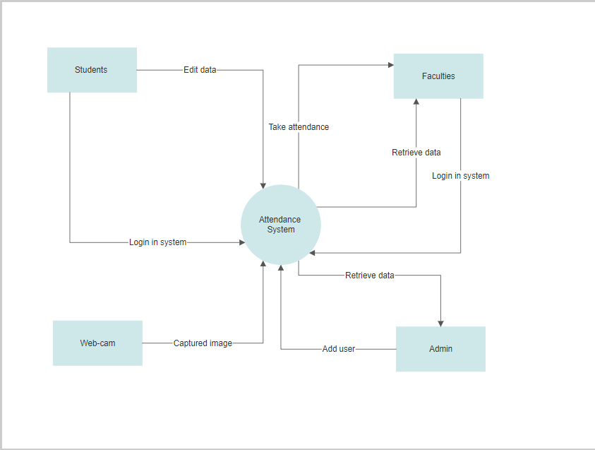
Level 1
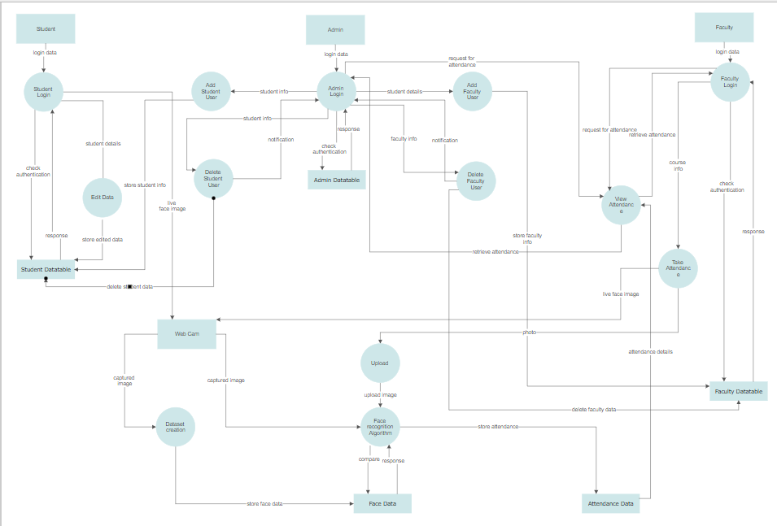
Level 2 Student
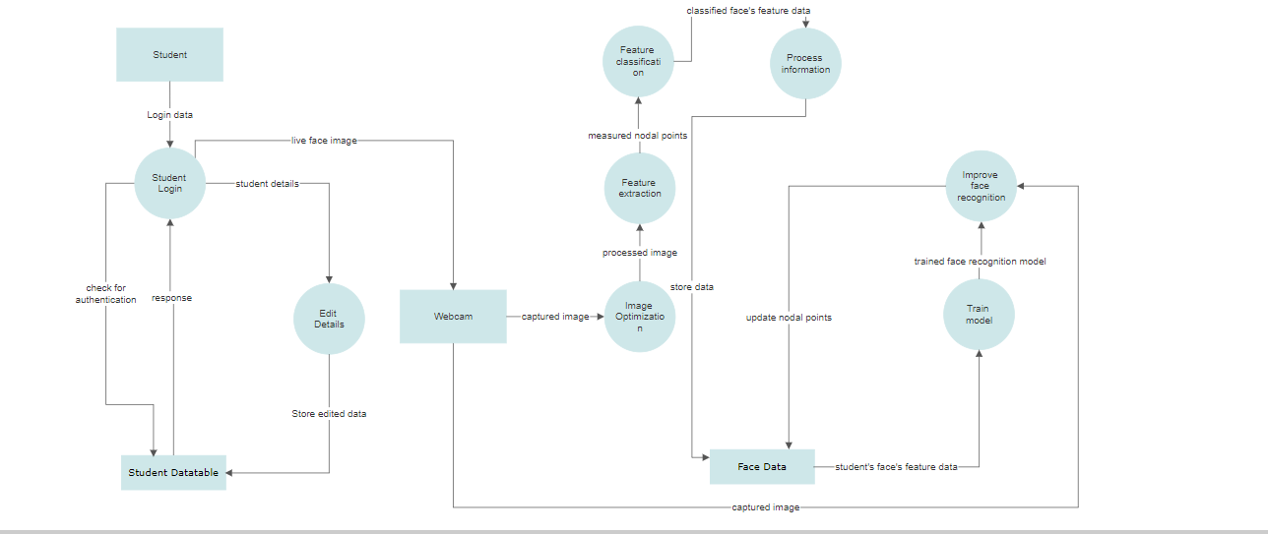

Level 2 Faculty
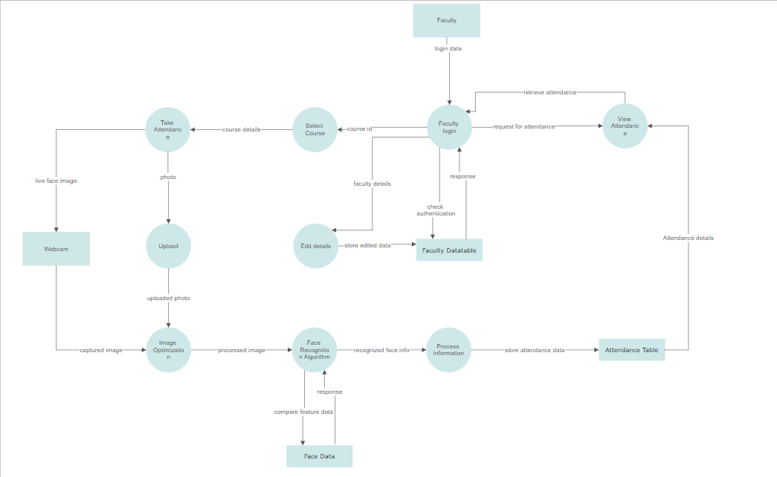
Level 2 Admin
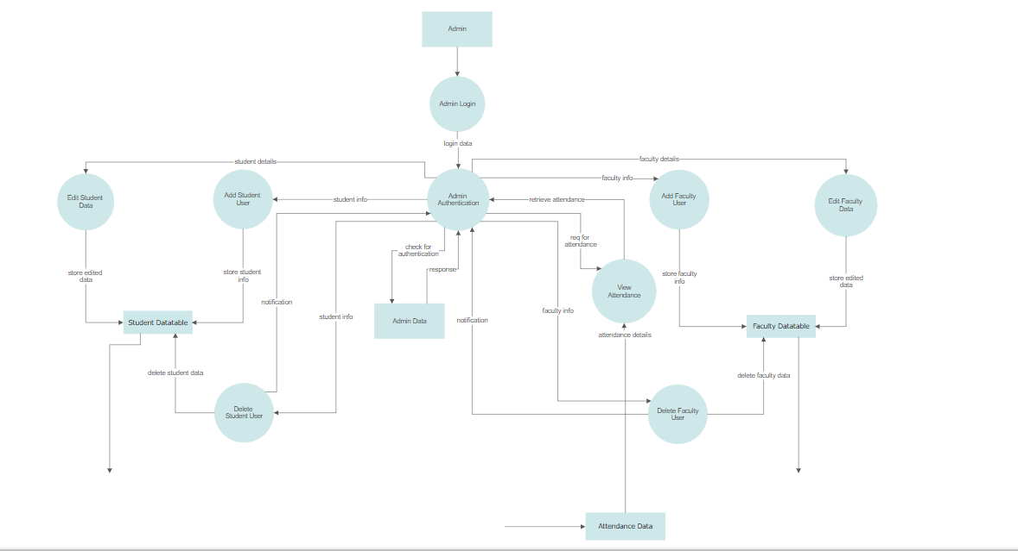
Appendix C: To Be Determined List
<Collect a numbered list of the TBD (to be determined) references that remain in the SRS so they can be tracked to closure.>

